**INNOVATE. CREATE. SOLVE**



Bengaluru, Karnataka, India

AN INTERNSHIP REPORT

ON

“Website for VDP solutions Pvt Ltd”

#### Bachelor of Engineering

#### In

#### Information Science and Engineering

#### 

#### Submitted by: NAGABUSHAN V(1AP18IS016)

#### 

#### 

**APS college of engineering**

#### 

#### 2021

## ABOUT THE COMPANY

IC Solution (ICS) is a digital service provider that aims to provide software, designing and marketing solutions to individuals and businesses. At ICS, we believe that service and quality is the key to success

We provide all kinds of technological and designing solutions from Billing Software to Web Designs or any custom demand that you may have. Experience the service like none other!

Some of our services include:

Development - We develop responsive, functional and super-fast websites.

We keep User Experience in mind while creating websites. A website should load quickly and should be accessible even on a small view-port and slow internet connection.

Mobile Application - We offer a wide range of professional Android, iOS & Hybrid app development services for our global clients, from a start up to a large enterprise.

Design - We offer professional Graphic design, Brochure design & Logo design. We are experts in crafting visual content to convey the right message to the customers.

Consultancy - We are here to provide you with expert advice on your design and development requirement.

Videos - We create a polished professional video that impresses your audience.

**TABLE OF CONTENTS**

Table of contents i

Overview of the Project 1

About VDP SOLUTION 2

Tools Used 3

Implementation 4

Snapshots 9

Bibliography 14

## OVERVIEW OF THE PROJECT

## Project Name: Website for VDP solutions Pvt Ltd

**Team Members:**

NAGABUSHAN V

## This project is based on Web Development And its Applications. The main objective of this project is to learn the implementation of HTML, CSS and JavaScript. The basic webpage of this project is created using HTML and styling of the webpage is done using CSS.

## This webpage is about one of the greatest companies of all time

## VDP Solutions Pvt Ltd

## VDP solutions is a digital service provider that aims to provide software, designing and marketing solutions to individuals and businesses. At VDP, it is believed that service and quality is the key to success. Founded and Funded by Graphic designers from Jahirathu Junction, VDP solution has now set a new path towards Digital Solution

## PRODUCTS

                         • Tea

                         • Lays

                         • Fair and Lovely

                         • Cigarette

                         • Good day Biscuit

                         • Panka

## ABOUT VDP SOLUTION

VDP Solutions., a growing IT company based and operating in Vijayawada, an obvious capital of the newly formed state in India was founded by wireless communication specialist entrepreneurs to address these challenges for new generation Internet Protocol (IP) connections.

Today's evolving communications and computer infrastructure presents a challenging environment for government, business and individual consumers alike. Given the frequency and sophistication of cyber-attacks on networks of all sizes and locations, a breach is almost guaranteed unless the right security solution is in place. An incident can put important company, employee and customer information at risk of being stolen or misused, thus leading to costly ramifications for the victim.

We envision our core technologies and methods becoming a de facto platform for protection, privacy, performance and flexibility over IP-based communications. Our offerings provide unprecedented network performance and security for a broad range of IP connections. Our customers, in turn, enjoy the value brought by significantly higher operating efficiencies, total "privacy" of application data and ensured protection of endpoints using traditional and next generation networks.

## Services Provided by VDP Solutions:

Development - We develop responsive, functional and super-fast websites.

We keep User Experience in mind while creating websites. A website should load

quickly and should be accessible even on a small view-port and slow internet

Connection

Mobile Application - We offer a wide range of professional Android, iOS & Hybrid app development services for our global clients, from a start up to a large

enterprise.

Design - We offer professional Graphic design, Brochure design & Logo design.

We are experts in crafting visual content to convey the right message to the customers. We also design custom wraps for your products (also known as

package designing)

Consultancy - We are here to provide you with expert advice on your design and

development requirement.

Videos - We create a polished professional video that impresses your audience.

Product photo shoot - We create a polished professional photo of the products that

impresses your audience.

Social Media Management: We will manage your social media with graphically

impressive posts and stories that helps you get better leads and increases popularity

## 

## HTML/PHP/CSS/JavaScript

## HTML

HTML is a markup language used for structuring and presenting content on the web and the fifth current major version of HTML standard. HTML5 includes detailed processing models to encourage more interoperable implementations; it extends, improves and rationalizes the markup available for documents, and introduces markup and application programming interfaces (APIs) for complex web applications.

#### PHP

PHP is a general-purpose scripting language especially suited to web development. The PHP reference implementation is now produced by The PHP Group. PHP originally stood for Personal Home Page, but it now stands for the recursive initialize PHP: Hypertext Preprocessor. Fast, flexible and pragmatic, PHP powers everything from your blog to the most popular websites in the world.

* **CSS**

Cascading Style Sheets (CSS) is a simple mechanism for adding style (e.g., fonts, colors and spacing) to Web documents. These pages contain information on how to learn and use CSS and on available software. They also contain news from the CSS working group.

## JavaScript

JavaScript often abbreviated as JS, is a high-level, interpreted programming language. It is a language which is also characterized as dynamic, weakly typed, prototype-based and multi-paradigm. Alongside HTML and CSS, JavaScript is one of the three core technologies of the World Wide Web. JavaScript enables interactive web pages and thus is an essential part of web applications. The vast majority of websites use it, and all major web browsers have a dedicated JavaScript engine to execute it.

# TOOLS USED

For good performance, you will at least need a Pentium 200-MHz computer with a

### Software Requirements

* Visual Studio Code 2019.
* Google Chrome or Microsoft Edge of latest version.
* Front End: HTML, CSS, JS (optional)
* Linux 7.1 or Windows XP/7/8/10 OS or Mac OS

### Hardware Requirements

* Pentium 200-MHz computer with a minimum of 64 MB of RAM (128 MB of RAM recommended).
* Monitor with a refresh rate of at least 40Hz for a smooth GUI experience (optional).

# IMPLEMENTATION

# Source Code (P2.HTML):

# <!DOCTYPE html>

# <html lang="en">

# <head>

# <title>Contact</title>

# <meta charset="utf-8" />

# <meta name="viewport" content="width=device-width, initial-scale=1" />

# {% load static %}

# <link

# rel="stylesheet"

# href="https://maxcdn.bootstrapcdn.com/bootstrap/3.4.1/css/bootstrap.min.css"

# />

# <link

# href="https://fonts.googleapis.com/CSS? Family=Montserrat"

# rel="stylesheet"

# type="text/CSS"

# />

# <link

# href="https://fonts.googleapis.com/CSS? Family=Late"

# rel="stylesheet"

# type="text/CSS"

# />

# <link

# rel="stylesheet"

# type="text/CSS"

# href="{% static 'CSS/styles.css' %}"

# />

# <scriptsrc="https://ajax.googleapis.com/ajax/libs/jquery/3.5.1/jquery.min.js"></script>

# <script src="https://maxcdn.bootstrapcdn.com/bootstrap/3.4.1/js/bootstrap.min.js"></script>

# </head>

# <body>

# <! -- As a heading -->

# <! -- <nav class="navbar navbar-light bg-light">

# <div class="container-fluid">

# <span class="navbar-brand mb-0 h1">Contact</span>

# </div>

# </nav>

# <br />

# <h1 class="text-center">Hello, world! </h1>

# <div class="container">

# <form class="" method="post">

# {% csrf_token %}

# <div class="form-group">

# <div class="mb-3">

# <label for="fname" class="form-label">Name</label>

# <input name="name" type="tezt" class="form-control" id="fname" placeholder="Enter Your Name" required>

# </div>

# <div class="mb-3">

# <label for="fnumber" class="form-label">Phone Number</label>

# <input name="number" type="number" class="form-control" id="fnumber" placeholder="Enter your Phone Number" required>

# </div>

# <div class="mb-3">

# <label for="exampleInputEmail1" class="form-label">Email</label>

# <input name="email" type="email" class="form-control" id="exampleInputEmail1" aria-describedby="emailHelp" placeholder="Enter your Email Address" required>

# </div>

# <div class="mb-3">

# <label for="subject" class="form-label">Subject</label>

# <input name="subject" class="form-control" id="subject"

# name="subject" placeholder="Write your Message here">

# </div>

# <button type="submit" class="btn btn-primary" value="Submit">Submit</button>

# </div>

# </form>

# </div> -->

# <! -- Optional JavaScript; choose one of the two! -->

# <! -- Option 1: Bootstrap Bundle with Popper -->

# <! -- <script

# src="https://cdn.jsdelivr.net/npm/bootstrap@5.0.2/dist/js/bootstrap.bundle.min.js"

# integrity="sha384-MrcW6ZMFYlzcLA8Nl+NtUVF0sA7MsXsP1UyJoMp4YLEuNSfAP+JcXn/tWtIaxVXM"

# crossorigin="anonymous"

# ></script> -->

# <!-- Option 2: Separate Popper and Bootstrap JS -->

# <!--

# <scriptsrc="https://cdn.jsdelivr.net/npm/@popperjs/core@2.9.2/dist/umd/popper.min.js" integrity="sha384-IQsoLXl5PILFhosVNubq5LC7Qb9DXgDA9i+tQ8Zj3iwWAwPtgFTxbJ8NT4GN1R8p" crossorigin="anonymous"></script>

# <scriptsrc="https://cdn.jsdelivr.net/npm/bootstrap@5.0.2/dist/js/bootstrap.min.js" integrity="sha384-cVKIPhGWiC2Al4u+LWgxfKTRIcfu0JTxR+EQDz/bgldoEyl4H0zUF0QKbrJ0EcQF" crossorigin="anonymous"></script>

# -->

# <nav class="navbar navbar-default navbar-fixed-top">

# <div class="container">

# <div class="navbar-header">

# <button

# type="button"

# class="navbar-toggle"

# data-toggle="collapse"

# data-target="#myNavbar"

# >

# <span class="icon-bar"></span>

# <span class="icon-bar"></span>

# <span class="icon-bar"></span>

# </button>

# <a class="navbar-brand" href="{% url 'index'%}">HOME</a>

# </div>

# <div class="collapse navbar-collapse" id="myNavbar">

# <ul class="nav navbar-nav navbar-right">

# <li><a href="{% url 'services'%}">SERVICES</a></li>

# <li><a href="{% url 'portfolio'%}">PORTFOLIO</a></li>

# <li><a href="{% url 'contact'%}">CONTACT</a></li>

# </ul>

# </div>

# </div>

# </nav>

# <div class="jumbotron text-center" style="height: auto; padding: 50px">

# <h1>Contact Us</h1>

# <p>we would love to hear it from you</p>

# </div>

# <div

# id="contact"

# class="container"

# style="max-height: 480px; padding-top: 50px; padding-bottom: 0px"

# >

# <div class="row">

# <div class="col-md-4"></div>

# <div class="col-md-4">

# <div class="row">

# <form class="" method="post">

# {% csrf_token %}

# <div class="col-sm-12 form-group">

# <input

# class="form-control"

# id="name"

# name="name"

# placeholder="Name"

# type="text"

# required

# />

# </div>

# <div class="col-sm-12 form-group">

# <input

# class="form-control"

# id="number"

# name="number"

# placeholder="Number"

# type="text"

# required

# />

# </div>

# <br />

# <div class="col-sm-12 form-group">

# <input

# class="form-control"

# id="email"

# name="email"

# placeholder="Email"

# type="email"

# required

# />

# </div>

# <div class="col-sm-12 form-group">

# <textarea

# class="form-control"

# id="subject"

# name="subject"

# placeholder="Subject"

# rows="5"

# ></textarea>

# </div>

# <br />

# <div class="col-sm-12 form-group">

# <button class="btn pull-right" type="submit">Send</button>

# </div>

# </form>

# </div>

# </div>

# <div class="col-md-4"></div>

# </div>

# </div>

# <footer

# class="container-fluid text-center"

# style="padding: 20px 0px; margin-top: 50px; background-color: #15123d"

# >

# <a href="#home" title="To Top">

# <span class="glyphicon glyphicon-chevron-up"></span>

# </a>

# <p>Copyright VDP Solutions 2021</p>

# </footer>

# <script>

# $(document). ready (function () {

# // Add smooth scrolling to all links in navbar + footer link

# $(“. navbar a, footer a[href='#home']"). On ("click", function (event) {

# // Make sure this. hash has a value before overriding default behavior

# if (this. hash! == "") {

# // Prevent default anchor click behavior

# event. prevent Default ();

# // Store hash

# var hash = this. Hash;

# // Using jQuery's animate () method to add smooth page scroll

# // The optional number (900) specifies the number of milliseconds it takes to scroll to the specified area

# $("html, body"). animate (

# {

# scroll Top: $(hash). Offset (). top,

# },

# 900,

# function () {

# // Add hash (#) to URL when done scrolling (default click behavior)

# window. location. hash= hash;

# }

# );

# } // End if

# });

# $(window). Scroll (function () {

# $(“. sildenafil"). Each (function () {

# var pos = $(this). offset (). top;

# var winTop = $(window).scrollTop();

# if (pos < winTop + 600) {

# $(this). addClass ("slide");

# }

# });

# });

# });

# var url = "{% static 'js/script.js' %}";

# var s = document. createElement("script");

# s. type = "text/javascript";

# s. async = true;

# s.src = url;

# var options = {

# enabled: true,

# chatButtonSetting: {

# backgroundColor: "#4dc247",

# ctaText: "",

# borderRadius: "25",

# marginLeft: "0",

# marginBottom: "30",

# marginRight: "20",

# position: "right",

# },

# brandSetting: {

# brandName: "VDP Solutions",

# brandSubTitle: "Typically replies within a day",

# brandImg: "{% static 'img/logo.jpg' %}",

# welcomeText: "Hi there! \nHow can I help you?",

# messageText: "Hello, I am interested in your Services.",

# backgroundColor: "#0a5f54",

# ctaText: "Start Chat",

# borderRadius: "25",

# autoShow: false,

# phoneNumber: "914345787247",

# },

# };

# s.onload = function () {

# CreateWhatsappChatWidget(options);

# };

# Var x= document. getElementsByTagName("script”) [0];

# x.parentNode.insertBefore(s, x);

# </script>

# </body>

# </html>

# IMPLEMENTATION

# Source Code (P2.CSS):

# body {

# font: 400 15px Lato, sans-serif;

# line-height: 1.8;

# color: #818181;

# }

# h2 {

# font-size: 24px;

# text-transform: uppercase;

# color: #303030;

# font-weight: 600;

# margin-bottom: 30px;

# }

# h4 {

# font-size: 19px;

# line-height: 1.375em;

# color: #303030;

# font-weight: 400;

# margin-bottom: 30px;

# }

# . helper {

# display: inline-block;

# height: 100%;

# vertical-align: middle;

# }

# . hero-img {

# vertical-align: middle;

# max-width: 100%;

# max-height: 100%;

# height: 480px;

# }

# . jumbotron {

# height: 100vh;

# /* margin-bottom: 30px; */

# background-color: #15123d;

# color: #fff;

# padding: 100px 25px;

# font-family: Montserrat, sans-serif;

# }

# .container-fluid {

# height: auto;

# padding: 60px 50px;

# }

# .bg-grey {

# background-color: #ffffff;

# }

# . logo-small {

# color: #f4511e;

# font-size: 50px;

# }

# . logo {

# color: #f4511e;

# font-size: 200px;

# }

# . thumbnail {

# padding: 0 0 15px 0;

# border: none;

# border-radius: 0;

# }

# . thumbnail img {

# width: 100%;

# height: 100%;

# margin-bottom: 10px;

# }

# . carousel-control. right,

# . carousel-control. Left {

# background-image: none;

# color: #f4511e;

# }

# . carousel-indicators li {

# border-color: #f4511e;

# }

# . carousel-indicators li. active {

# background-color: #f4511e;

# }

# . item h4 {

# font-size: 19px;

# line-height: 1.375em;

# font-weight: 400;

# font-style: italic;

# margin: 70px 0;

# }

# . item span {

# font-style: normal;

# }

# .panel {

# border: 1px solid #f4511e;

# border-radius: 0! important;

# transition: box-shadow 0.5s;

# }

# . panel: hover {

# box-shadow: 5px 0px 40px rgba (0, 0, 0, 0.2);

# }

# . panel-footer. btn: hover {

# border: 1px solid #f4511e;

# background-color: #fff! important;

# color: #f4511e;

# }

# . panel-heading {

# color: #fff! important;

# background-color: #f4511e! important;

# padding: 25px;

# border-bottom: 1px solid transparent;

# border-top-left-radius: 0px;

# border-top-right-radius: 0px;

# border-bottom-left-radius: 0px;

# border-bottom-right-radius: 0px;

# }

# . panel-footer {

# background-color: white! important;

# }

# . panel-footer h3 {

# font-size: 32px;

# }

# . panel-footer h4 {

# color: #aaa;

# font-size: 14px;

# }

# . panel-footer. btn {

# margin: 15px 0;

# background-color: #f4511e;

# color: #fff;

# }

# . navbar {

# margin-bottom: 0;

# background-color: #15123d;

# z-index: 9999;

# border: 0;

# font-size: 12px! important;

# line-height: 1.42857143! important;

# letter-spacing: 4px;

# border-radius: 0;

# font-family: Montserrat, sans-serif;

# }

# . navbar li a,

# . navbar {

# color: #fff! important;

# }

# . navbar-nav li a: hover,

# . navbar-header a: hover {

# color: #000000! important;

# background-color: #fff! important;

# }

# . navbar-default. navbar-toggle {

# border-color: transparent;

# color: #fff !important;

# }

# .nav-tabs li a {

# color: #777;

# }

# .navbar-default. navbar-nav >. active > a {

# background-color: transparent;

# }

# footer {

# position: relative;

# bottom: 0;

# width: 100%;

# }

# footer. glyphicon {

# background-color: #15123d;

# color: #f5f5f5;

# /* padding: 32px; */

# }

# footer a {

# color: #f5f5f5;

# }

# footer a: hover {

# color: #777;

# text-decoration: none;

# }

# . carousel-inner img {

# 

# IMPLEMENTATION

# Snapshots:

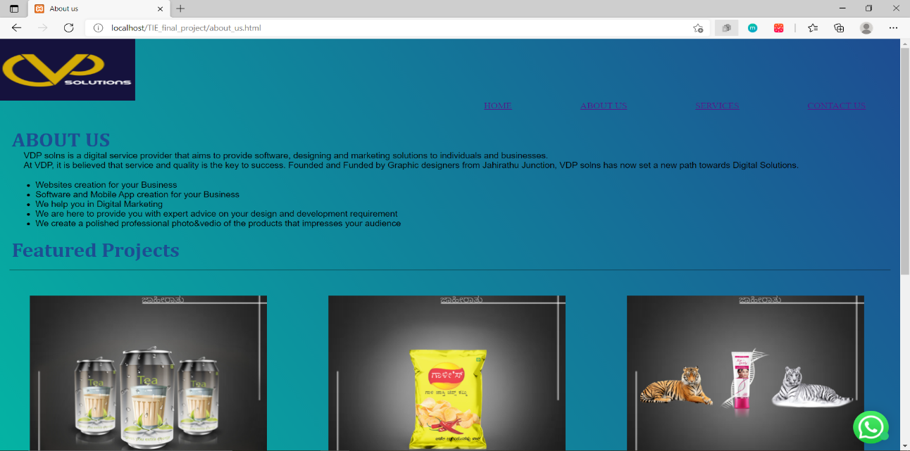

**About Us**

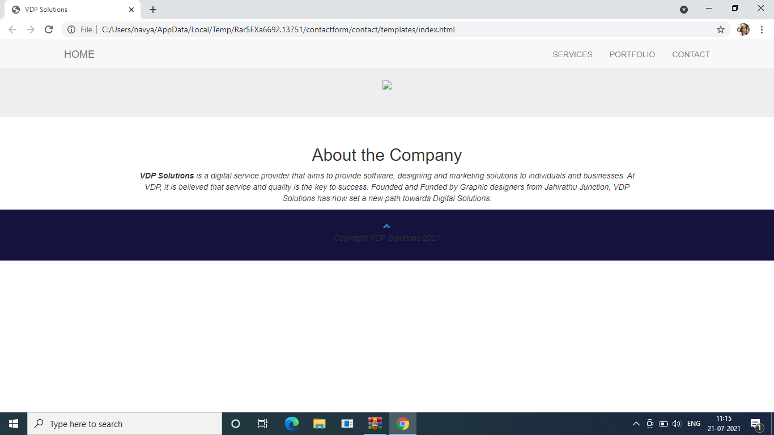

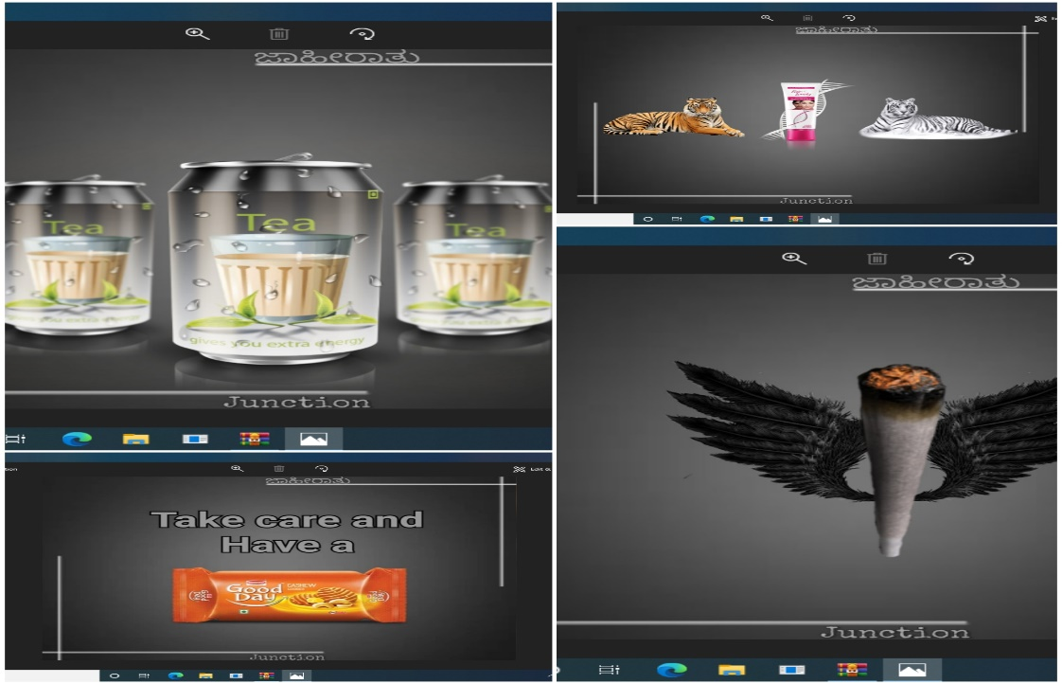

Gallery

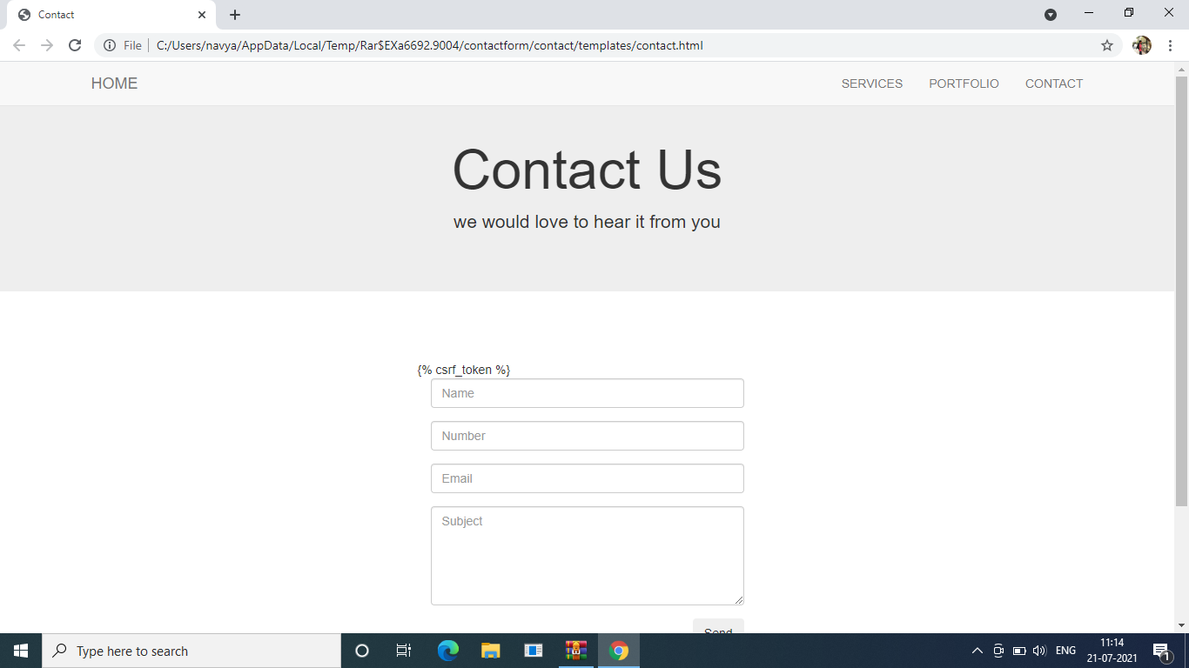

Contact us

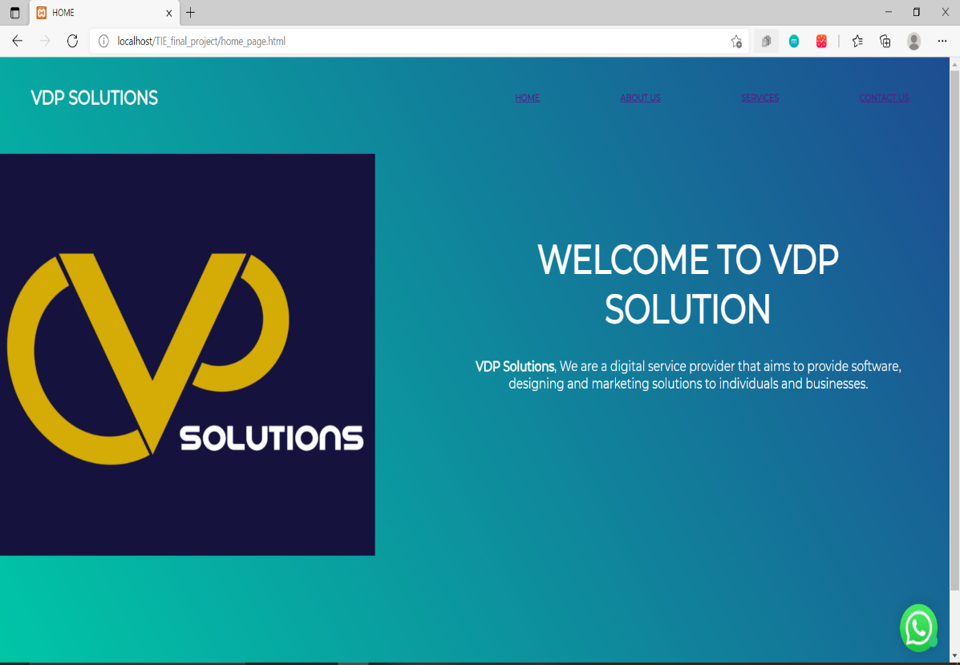

**Home Page**

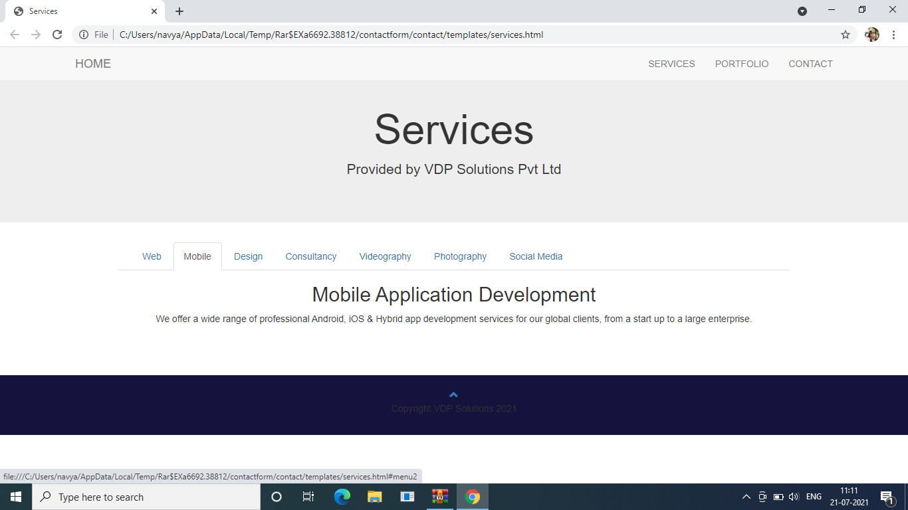

**Services**

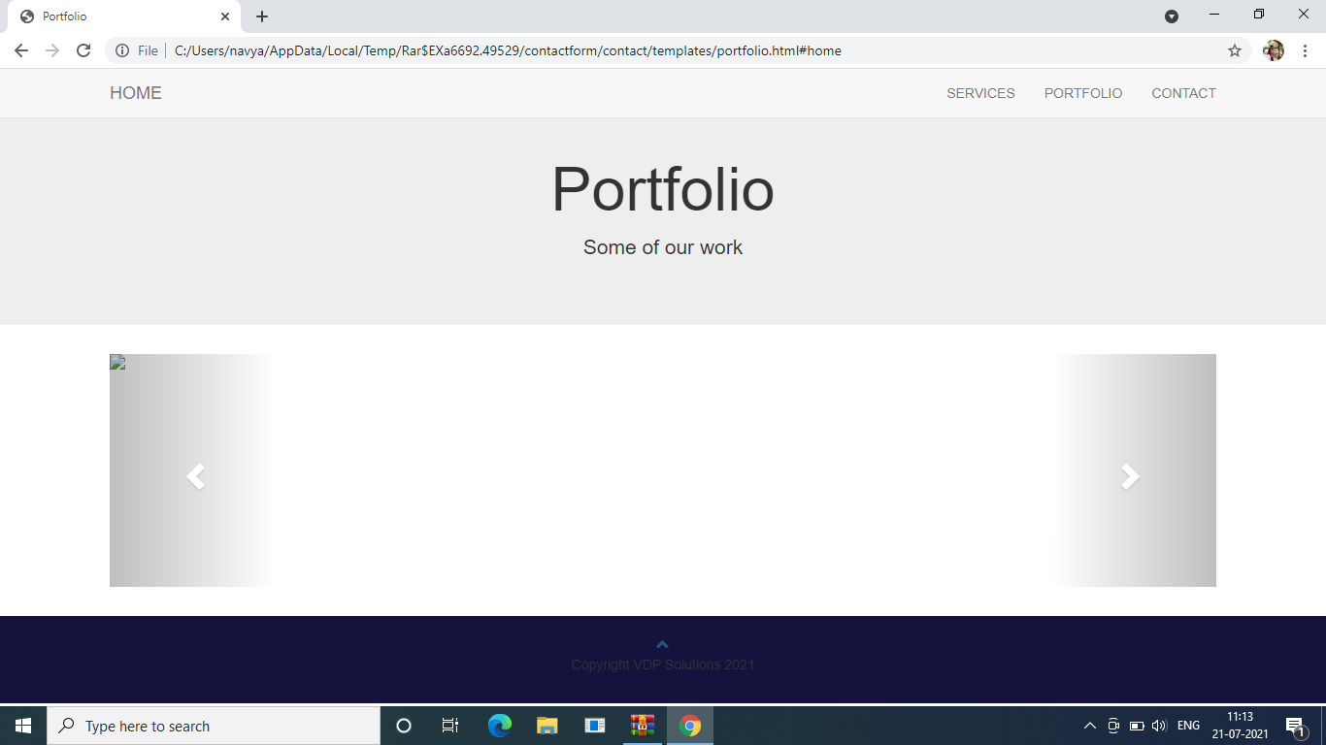

**Portfolio**

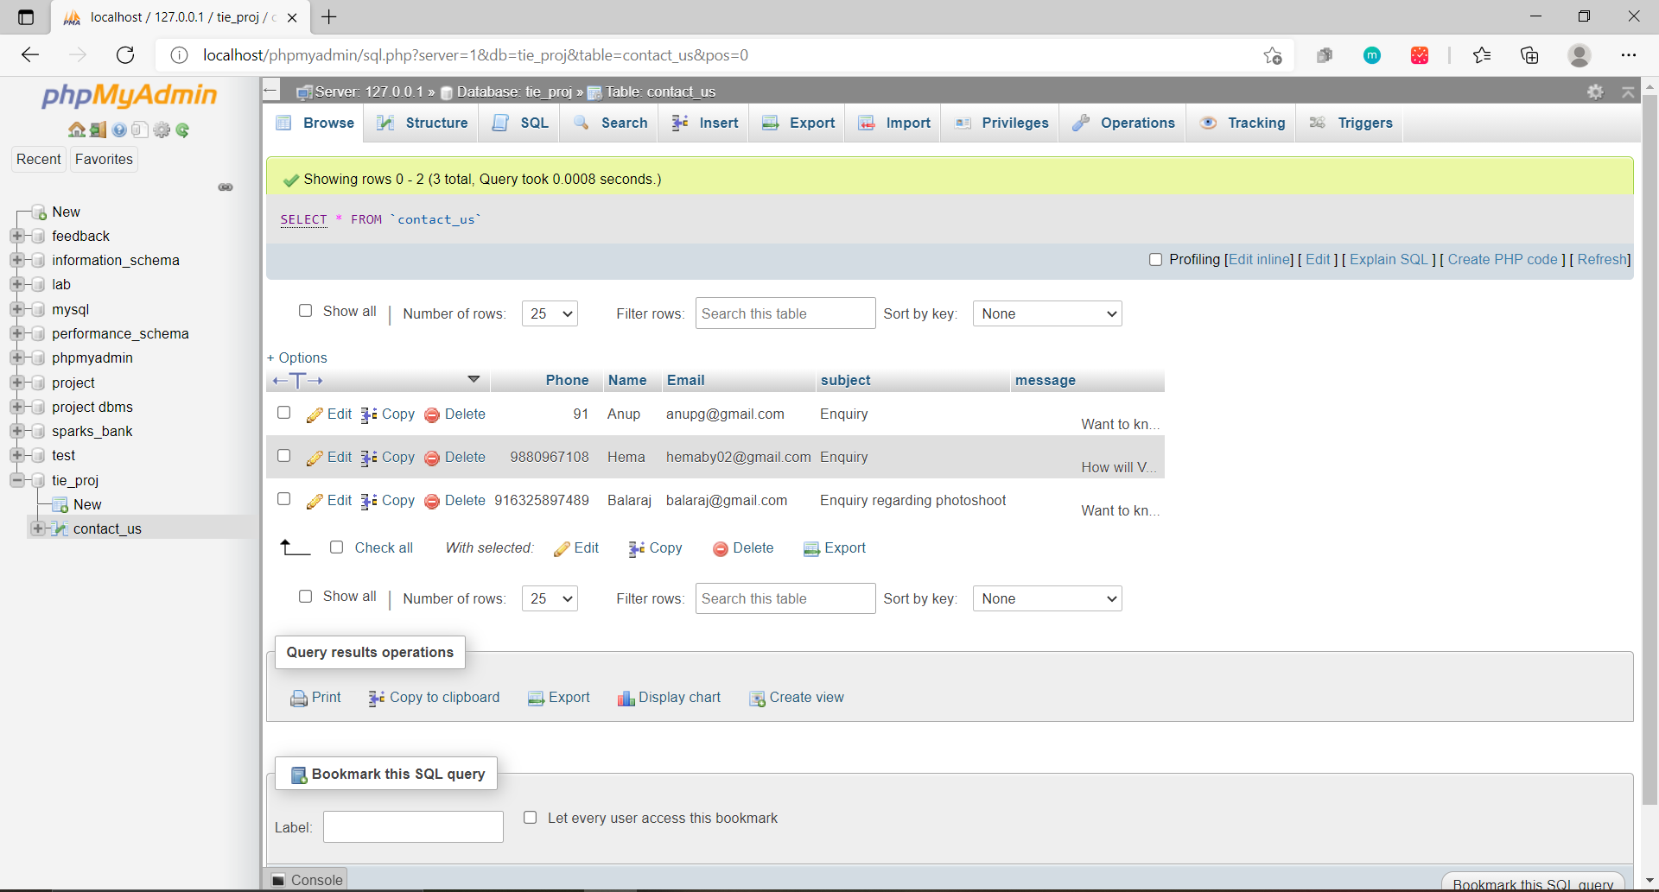

**Database**

**BIBLIOGRAPHY**

* References for HTML, CSS, and JavaScript in W3Schools - https://[www.w3schools.com](http://www.w3schools.com/)/
* References for CSS and HTML – http://www.w3schools.com/html/html_css.asp
* https://[www.geeksforgeeks.org](http://www.geeksforgeeks.org/)
* https://freefrontend.com